Name:_____________________

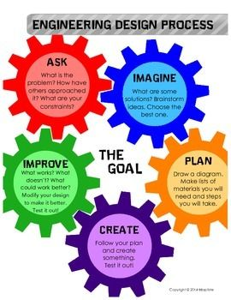

**Catapult Design Challenge**

**What is the challenge?**

To design a catapult that will move materials from one place to another.

**Possible Materials:**

* Large and small craft sticks
* Rubber bands or hair elastics
* Binder clips
* Plastic spoon
* Plastic cup
* Clothespin
* Scissors
* Ruler
* Ask Mrs. Kenney if you need help substituting materials

**Imagine and Plan: (6 points)**

1. How could you build it?
2. What materials are you using?
3. What does a catapult do?
4. How does a catapult work?
5. What type of simple machine is it? How do you know?

**Create: Build your catapult (2 points)**

1. Build your catapult and take a picture of it.

**Test: (4 points)**

1. What items are you launching?
2. How far can you launch objects?

**Evaluate: (4 points)**

1. What worked well in your design? Give at least three specific things and tell me how or why each thing worked well. For example, do not not say binder clips worked well, instead explain how you used binder clips to make them work well. Please be detailed.
2. What could you do to improve your design?

**Reflect: (4 points)**

1. What one material do you think made the biggest difference in creating a successful catapult? Explain why you chose that one.
2. What forces were used to move the projectile- pushes or pulls? Explain your answer by giving examples using your catapult design.
3. What happens to the projectile if no force is applied? Why?
4. What would you do differently next time and why?